https://www1.gsis.gr/sgsisapps/eparavolo/public/welcome.htm
Go to this link

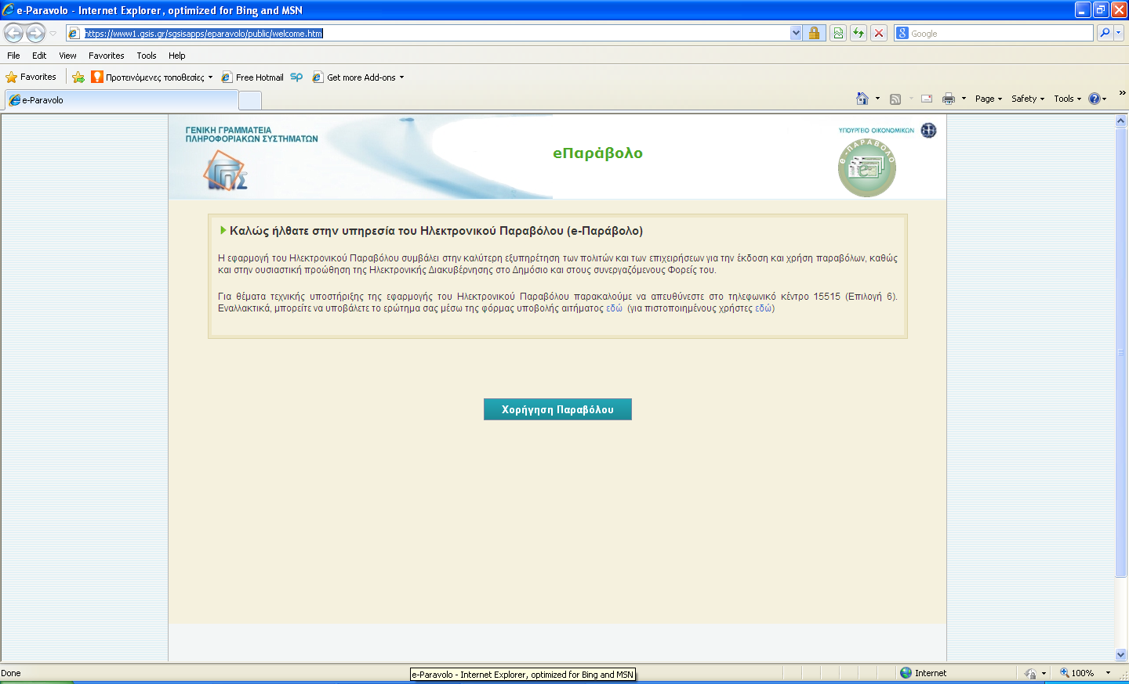
Click here
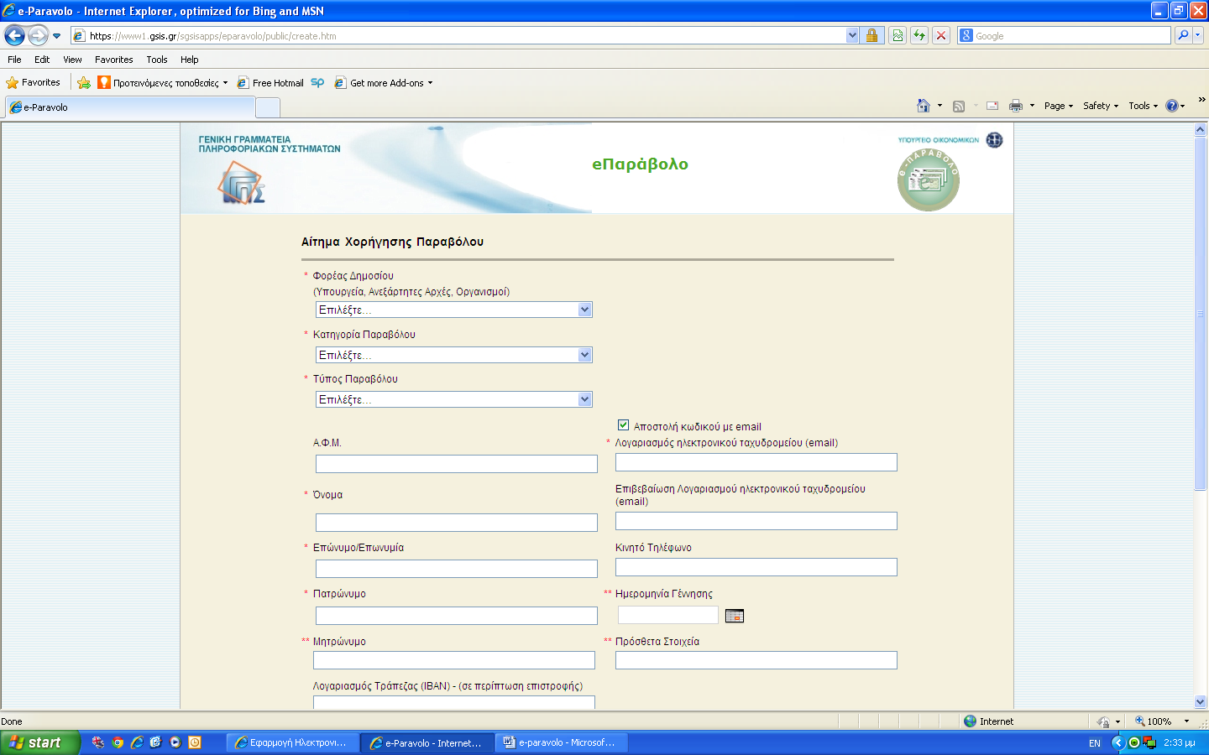
Select from pop-out menus (see next pages)
National Authority
Fee category
Fee type
VAT No
First Name
Surname / Company’s name
Surname / Company’s name
Mother’s name
email
Confirm email
Mobile phone
Date of Birth
Additional data
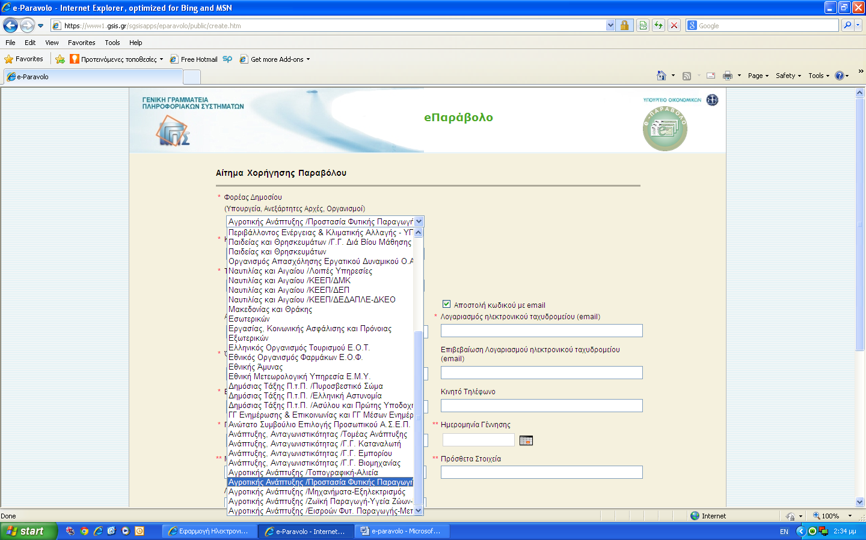
Ministry of Rural Development and Food,/ Plant Protection Directorate
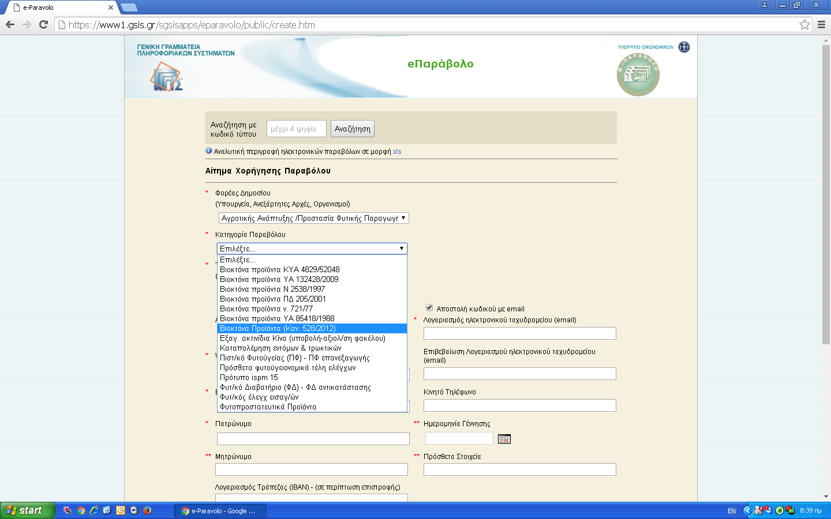

Select this for BPR Procedures
In the fee type popup menu, select the relevant fee using the numbering code according to the list of the fees document (see next pages):

Examples are given below (the numbering code is presented in bold):
- ΚΥΑ 4616/52519 άρθρο. 15 (περ. Α.1) corresponds to “Evaluation of an active substance (chemical substance) for a single PT”
- ΚΥΑ 4616/52519 άρθρο. 15 (περ. Α.9) corresponds to “Renewal of an active substance (microorganism) in case that evaluation is required”
- ΚΥΑ 4616/52519 άρθρο. 15 (περ. B.1) corresponds to “Evaluation of a Biocidal product when Greece acts as RMS”
- ΚΥΑ 4616/52519 άρθρο. 15 (περ. B.9) corresponds to “Mutual Recognition of Biocidal product”
- ΚΥΑ 4616/52519 άρθρο. 15 (περ. B.25) corresponds to “Minor change for a single Biocidal product, when Greece acts as a RMS”

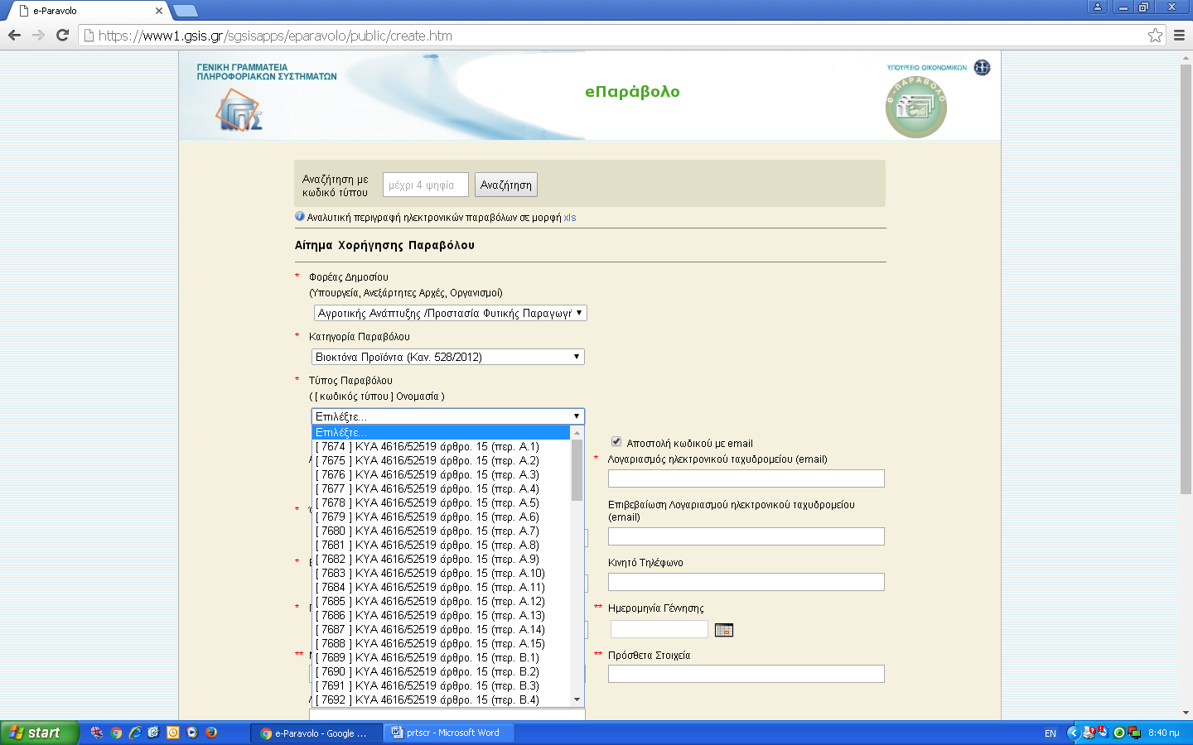
LIST OF BPR FEES IN GREECE

Α. ACTIVE SUBSTANCES
- Evaluation of an active substance (chemical substance) for a single PT: 100.000 €.
- Evaluation of an active substance (microorganism) for a single PT: 50.000 €.
- Evaluation of an active substance (chemical compound) for additional PTs: 50.000 € / per PT.
- Evaluation of an active substance (microorganism) for additional PTs: 25.000 €/ PT.
- Evaluation of an active substance for inclusion in Annex I of BPR: 10.000 €.
- Renewal or Change in the conditions of approval of an active substance, which is included in Annex I of BPR, in case that Greece acts as Ref MS: 5.000 €.
- Change in the conditions of approval of an active substance, except for the PT, in case that Greece acts as Ref MS (10.000) €.
- Renewal of an active substance (chemical substance) in case that evaluation is required: 100.000 €.
- Renewal of an active substance (microorganism) in case that evaluation is required 50.000 €.
- Renewal of an active substance (chemical substance) in case that evaluation is not required: 50.000 €.
- Renewal of an active substance (microorganism) in case that evaluation is not required: 25.000 €.
- Evaluation of an approved active substance (chemical compound) for additional PTs: 50.000 € per PT.
- Evaluation of an approved active substance (microorganism) for additional PTs: 50.000 € per PT: 25.000 € per PT.
- Evaluation of an approved active substance (chemical compound) for additional PTs, but Greece was not the Ref MS: 75.000 € per PT.
- Evaluation of an approved active substance (chemical compound) for additional PTs, but Greece was not the Ref MS: 35.000 € per PT.

Β. BIOCIDAL PRODUCTS
UNION AUTHORIZATION (articles 41- 44 of BPR)
- Evaluation of a Biocidal product when Greece acts as RMS: 20.000 €.
- Evaluation of Biocidal product, which is the same as that used for the evaluation of the active substance and Greece acted as RMS: 4.000 €.
- Evaluation of a Biocidal product family when Greece acts as RMS 40.000 €.

NATIONAL AUTHORIZATION (articles 29 and 30 of BPR)
- Evaluation of a Biocidal product when Greece acts as RMS: 20.000 €.
- Evaluation of Biocidal product, which is the same as that used for the evaluation of the active substance and Greece acted as RMS: 4.000 €.
- Evaluation of Biocidal product, which is the same as that used for the evaluation of the active substance and Greece had not acted as RMS: 10.000 €.
- Evaluation of a Biocidal product family when Greece acts as RMS: 40.000 €.
- Notification of a new product belonging to an authorized family: 600 € per notification.

MUTUAL RECOGNITION PROCEDURE
- Mutual Recognition of Biocidal product: 2.500 €.
- Mutual Recognition of Biocidal product family: 5.000 €.

SIMPLIFIED PROCEDURE
- Evaluation of a Biocidal product according to the simplified procedure: 2.000 €.
- Evaluation of a Biocidal product according to the simplified procedure which was the same as that used for the evaluation of the active substance and Greece acted as RMS: 600 €.
- Evaluation of a Biocidal product according to the simplified procedure which was the same as that used for the evaluation of the active substance and Greece had not acted as RMS: 1.000 €.
- Evaluation of a Biocidal product family according to the simplified procedure: 4.000 €.
- Notification for placing on the market of a biocidal product that has been authorized in EU according to the simplified procedure: 400 €.
- Notification for placing on the market of a biocidal product family that has been authorized in EU according to the simplified procedure: 800 €.
- Addition of a new product to an already authorized Biocidal product family, which is authorized according to the simplified procedure: 200 €.

PROVISIONAL AUTHORIZATIONS (article 55.2 of BPR)
- Single biocidal product: 2.000 €.
- Single biocidal product, which is the same as that used in the evaluation of the active substance: 400 €.
- Biocidal product family: 4.000 €.
- Notification of a new product to an already authorized Biocidal product family: 200 €.

SAME BIOCIDAL PRODUCTS
- Single biocidal product: 1.600 €.
- Biocidal product family: 3.200 €.

CHANGES TO AUTHORIZATIONS
- Administrative change for a single Biocidal product: 200 € per product.
- Minor change for a single Biocidal product, when Greece acts as a RMS: 1.200 € per product.
- Minor change for a single Biocidal product, when Greece does not act as a RMS: 600 € per product.
- Major change for a single Biocidal product, when Greece acts as a RMS: 8.000 € per product.
- Major change for a single Biocidal product, when Greece does not act as a RMS 1.000 € per product.
- Major change for a single Biocidal product authorized according to Union Authorization, when Greece acts as a RMS 8.000 € per product.
- Administrative change for a Biocidal product family: 400 € per product family.
- Minor change for a Biocidal product family, when Greece acts as a RMS: 2.400 € per product family.
- Minor change for a Biocidal product family, when Greece does not act as a RMS 1.200 € per product family.
- Major change for a Biocidal product family, when Greece acts as a RMS: 16.000 € per product family.
- Major change for a Biocidal product family, when Greece doesn’t act as a RMS: 2.400 € per product family.
- Major change for a Biocidal product family authorized according to Union Authorization, when Greece acts as a RMS 16.000 € per product family.
- Administrative change for a single Biocidal product authorized according to the simplified procedure: 200 € per product.
- Minor change for a single Biocidal product authorized according to the simplified procedure and Greece acts as RMS: 300 € per product.
- Minor change for a single Biocidal product authorized according to the simplified procedure and Greece does not act as RMS: 200 € per product.
- Major change for a single Biocidal product authorized according to the simplified procedure and Greece acts as RMS: 800 € per product.
- Major change for a single Biocidal product authorized according to the simplified procedure and Greece does not act as RMS: 300 € ανά προϊόν.
- Administrative change for a Biocidal product family authorized according to the simplified procedure: 300 € per product family.
- Minor change for a Biocidal product family authorized according to the simplified procedure and Greece acts as RMS: 600 € per product family.
- Minor change for a Biocidal product family authorized according to the simplified procedure and Greece does not act as RMS: 400 € per product family.
- Major change for a Biocidal product family authorized according to the simplified procedure and Greece acts as RMS: 1.600 € per product family.
- Major change for a Biocidal product family authorized according to the simplified procedure and Greece does not act as RMS : 600 € per product family.

RENEWALS OF THE BIOCIDAL PRODUCTS
NATIONAL AUTHORIZATIONS / UNION AUTHORIZATIONS
- Renewal of a single Biocidal product when evaluation is required: 15.000 €.
- Renewal of a Biocidal product family when evaluation is required: 30.000 €.
- Renewal of a single Biocidal product when evaluation is not required: 5.000 €.
- Renewal of a Biocidal product family when evaluation is not required: 10.000 €.

MUTUAL RECOGNITION
- Renewal of a single Biocidal product: 1.800 €.
- Renewal of a Biocidal product family: 3.600 €.

SIMPLIFIED PROCEDURE
- Renewal of a single Biocidal product when evaluation is required: 1500 €.
- Renewal of a Biocidal product family when evaluation is required: 3.000 €.
- Renewal of a single Biocidal product when evaluation is not required: 500 €.
- Renewal of a Biocidal product family when evaluation is not required: 1.000 €.

SAME PRODUCTS
- Renewal of a single Biocidal product: 200 €.
- Renewal of a Biocidal product family: 300 €.

MRLs
58. Evaluation of a data set (analytical methods, toxicological studies, residues) with a view to set Maximum Residue Limits (MRLs) for a non approved active substance:
α) Completeness check of the dossier: 500 €.
β) Evaluation of the data set: 2.000 €.
- Evaluation of a data set (analytical methods, toxicological studies, residues) with a view to set Maximum Residue Limits (MRLs) for an approved active substance:
α) Completeness check of the dossier: 500 €.
β) Evaluation of the data set: 2.000 €.

COMPARATIVE RISK ASSESSMENT
- Comparative risk assessment for Union Authorization Procedures for a single Biocidal product: 6.000 €
- Comparative risk assessment for Union Authorization Procedures for a Biocidal product family: 12.000 €
- Comparative risk assessment for National authorization for a single Biocidal product: 6.000 €
- Comparative risk assessment for National authorization for a Biocidal product family: 12.000 €

PARALLEL TRADE
- Fees for parallel trade: 2.000 €

EXPERIMENTAL PERMIT
- Fees for experimental permit: 500 €

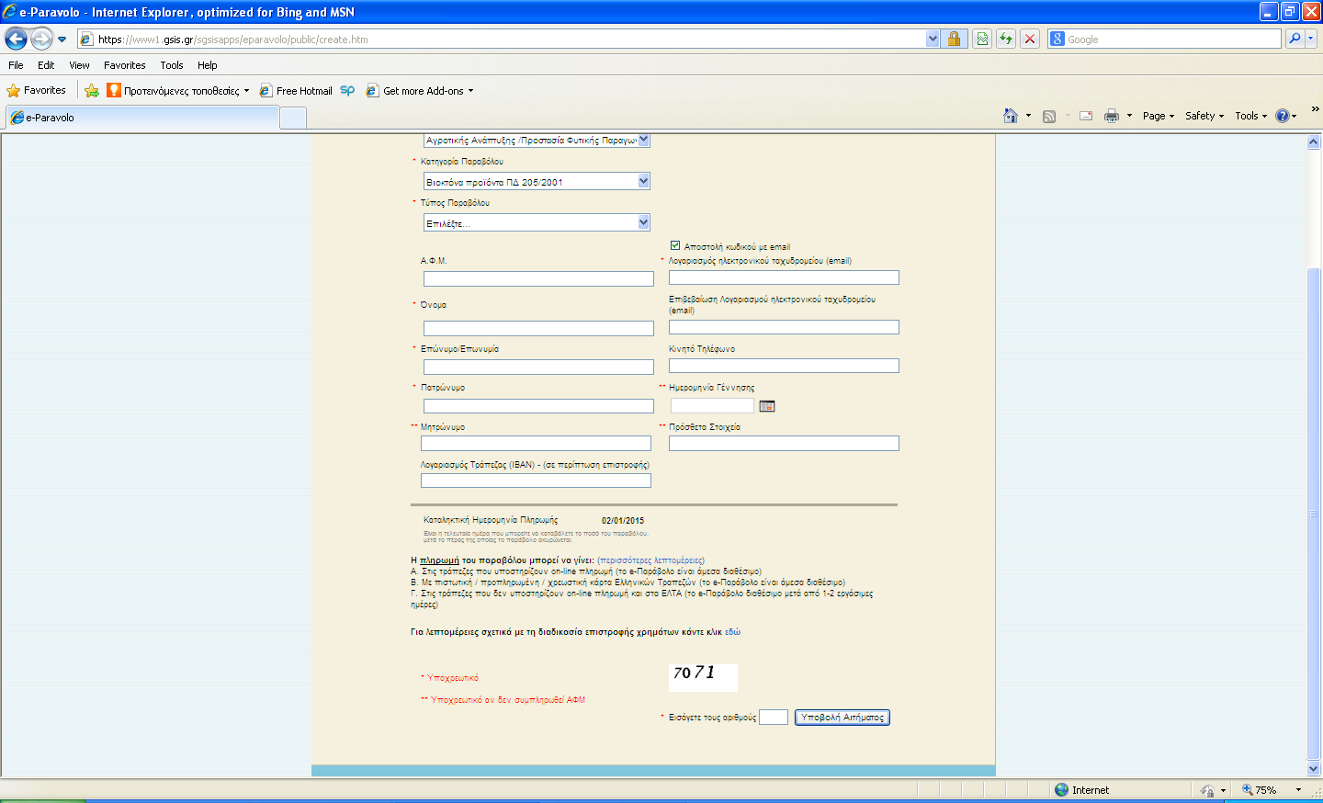
IBAN (It will be used in case of fee refunding)
Payment must be facilitated by that date
Submit
Insert the Captcha of the box on the left
After submission the applicant will receive by email the unique fee-code for facilitating the payment. The applicants must keep the unique fee-code and demonstrate it to the bank during the fee payment. Payment can be facilitated as follows:
1. Directly through the following banks which are seated in Greece:
ALPHA BANK
NATIONAL BANK OF GREECE
ATTICA BANK
PIREAUS BANK
If payment is facilitated through a different than the abovementioned banks, the fee invoice will be available after 1-2 working days from the payment. The applicants are suggested that they use banks seated in Greece.
2. Through Credit or Prepaid card. The fee payment can be facilitated through the web site of the fee (e-paravolo) application.

Once the fee payment is accomplished the applicant will then receive the fee invoice.
The applicant must submit a copy of the fee invoice to the Greek CA for biocides along with the remainder documents of his application.

